DEPARTMENT OF HINDI
ENDOWMENT LECTURE SERIES
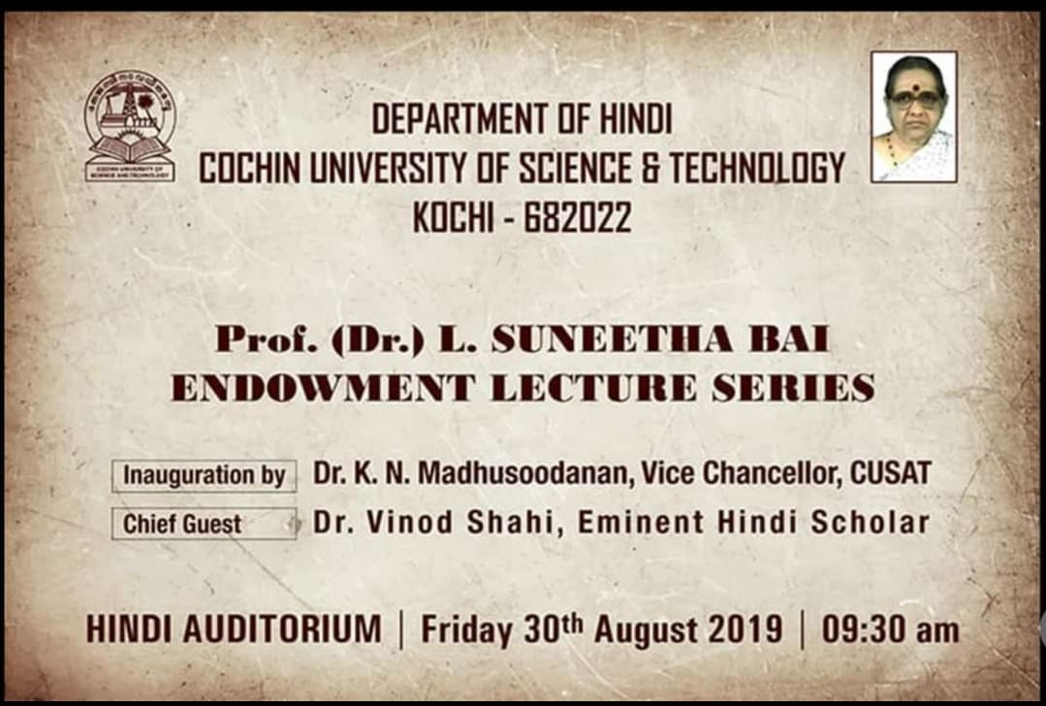

The Department of Hindi conducting Prof.(Dr.) L. Suneetha Bai Endowment Lecture Series every year.This Endowment is instituted by her spouse Sri.Adv.Balakrishna Shenoy,for co-memorating Prof.Dr.L.Suneetha Bai.As part of this series an Endowment is named ‘Dr.L.Suneetha Bai Gyan Puraskar’ is conducting for the best literary critic from Keralite Hindi Authors and ‘Dr.L.Suneetha Bai Medha Puraskar’ for the students who secured first and second positions in final year M A Examinations .This lecture series was started from 30 August 2019 and still now it’s continuing with the presence of famous Hindi Writers.

Prof.[Dr.] L. SUNEETHA BAI ENDOWMENT LECTURE SERIES - 2019
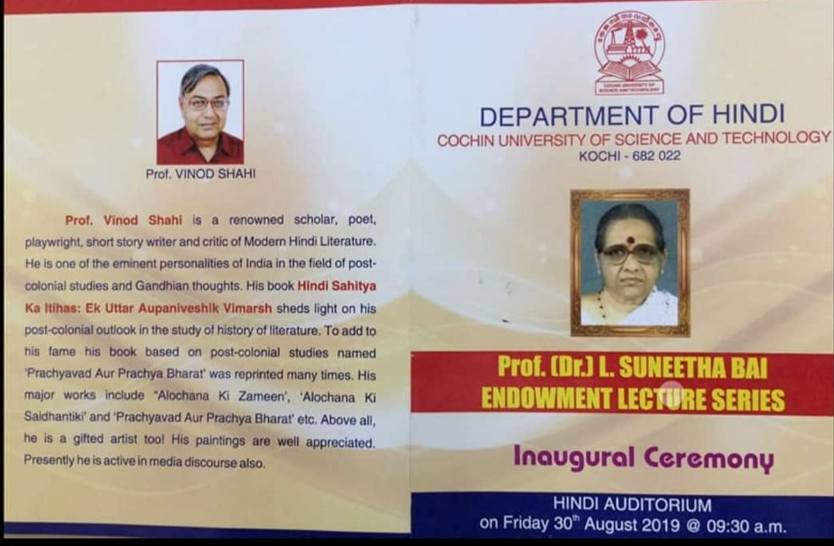

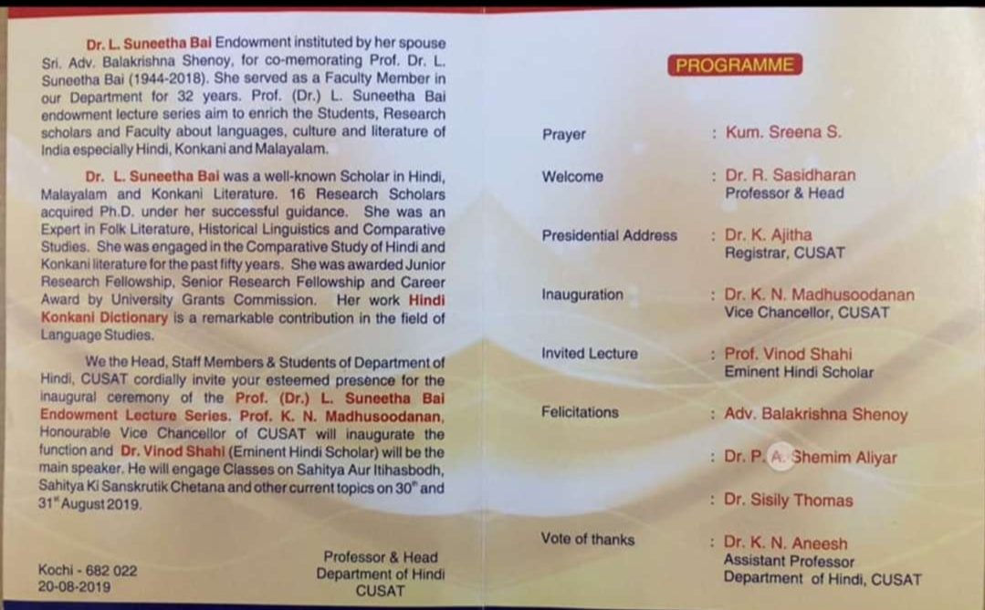

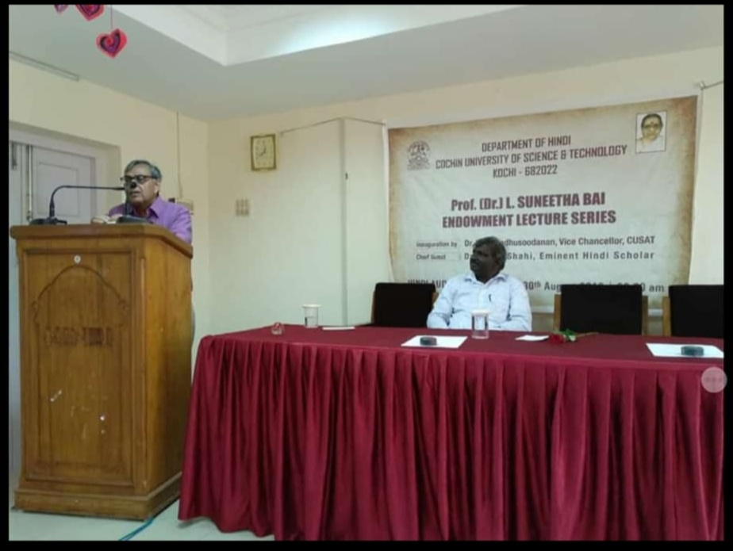
Prof.[Dr.] L. SUNEETHA BAI ENDOWMENT LECTURE SERIES - 2021

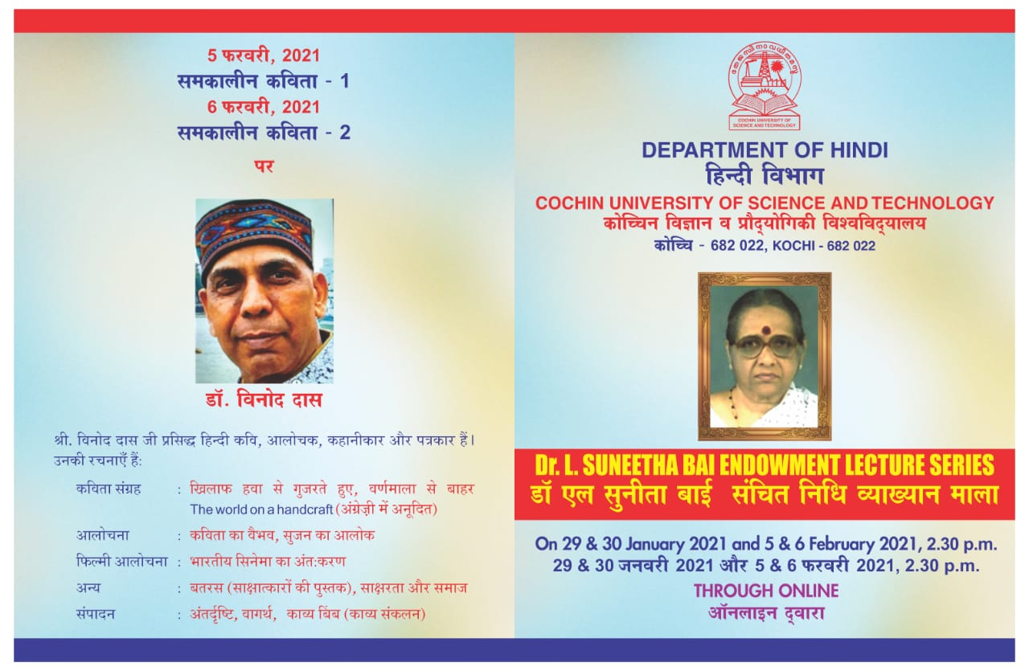

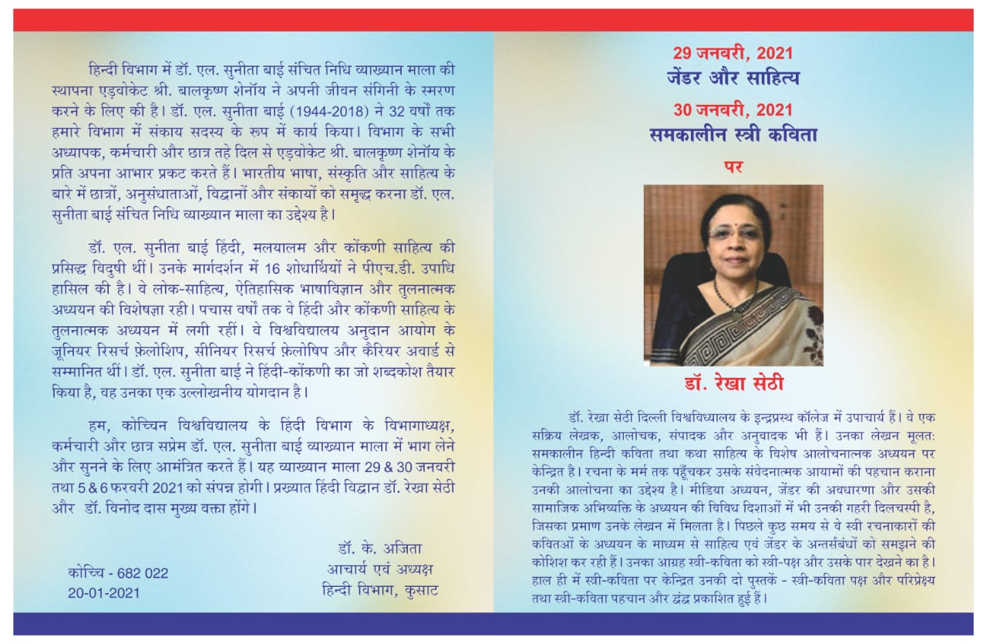

Prof.[Dr.] L. SUNEETHA BAI ENDOWMENT LECTURE SERIES - 2021
